Scissor Design

Force analysis and dimension assume:

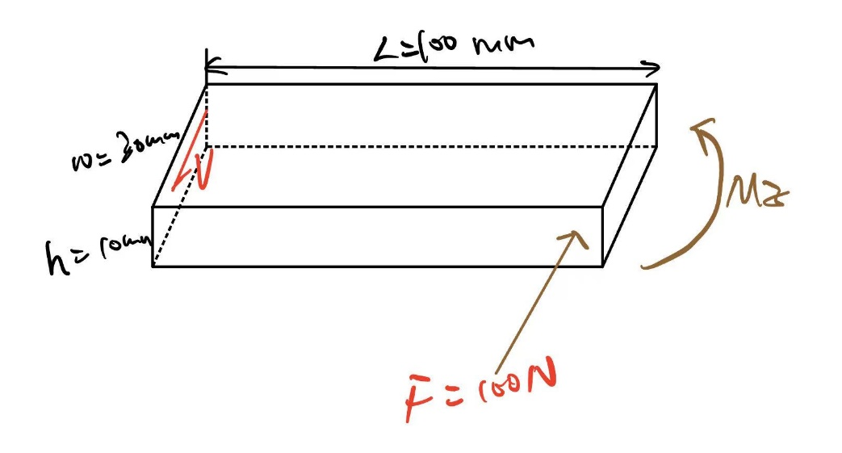

(Need solid work more accurate figure)

The dimension of scissor is L=100m, w=30mm, and h=10m

The force required when cutting durian branches at the bottom of scissor arm:

And calculate the moment at the top of the scissor arm:

And then check for the yielding:

Choose the safety factor as

The second moment of area:

The first moment of area:

Bending stress:

Normal:

Shear:

And choose the 1030 HR steel for the scissor, the porosities of the material from Shigley’s book Table A-20:



The density of 1030 HR steel is

Since it’s a ductile material, choose Distortion-energy criterion:

Thus, the beam will not yield.